Problem 1 Testing Screenshot and Answers to Subproblems:

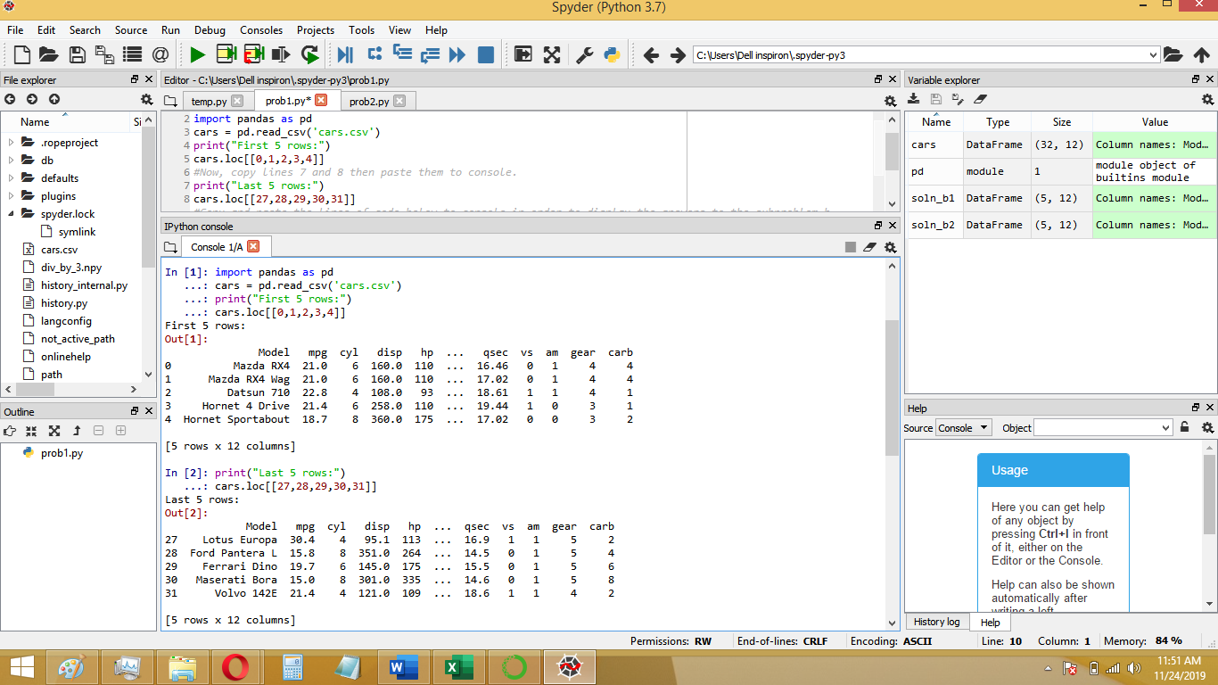

a.)

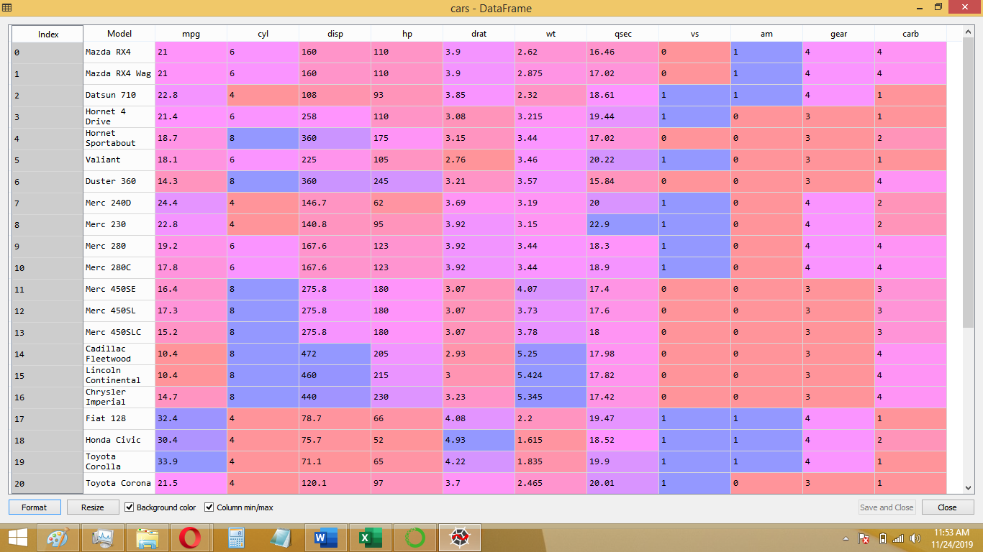

b.)

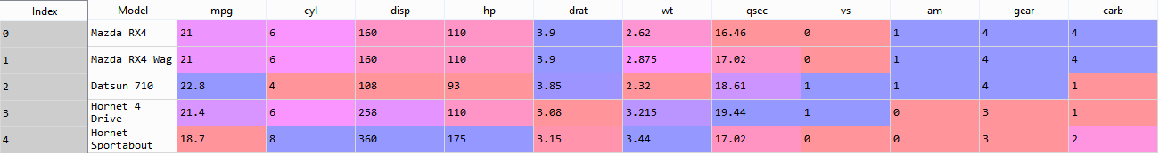

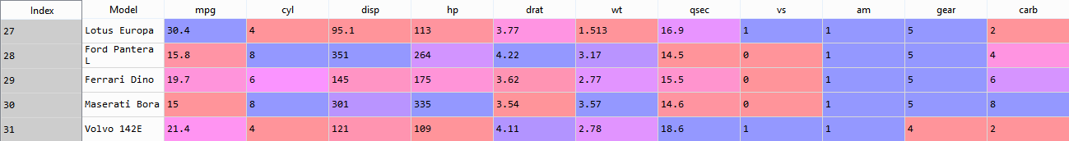

Problem 2 Testing Screenshots and Answers to Subproblems:

a.)

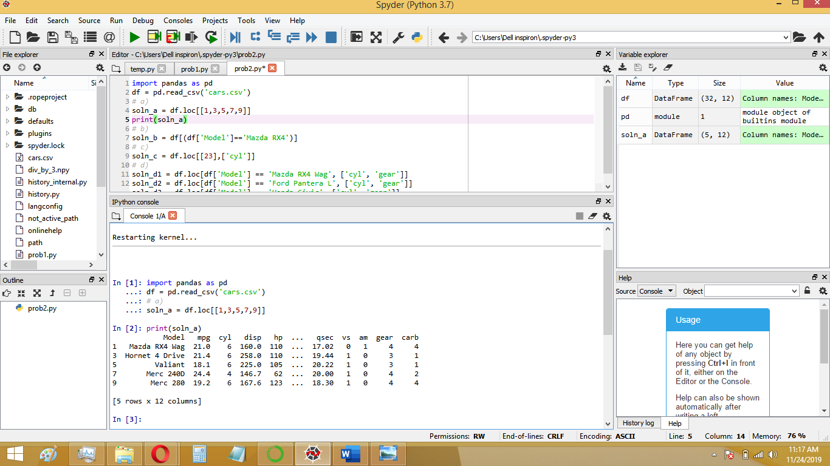

Answer (on next page):

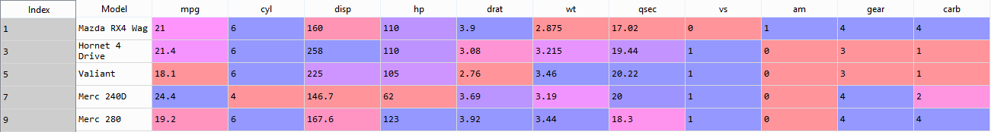b.)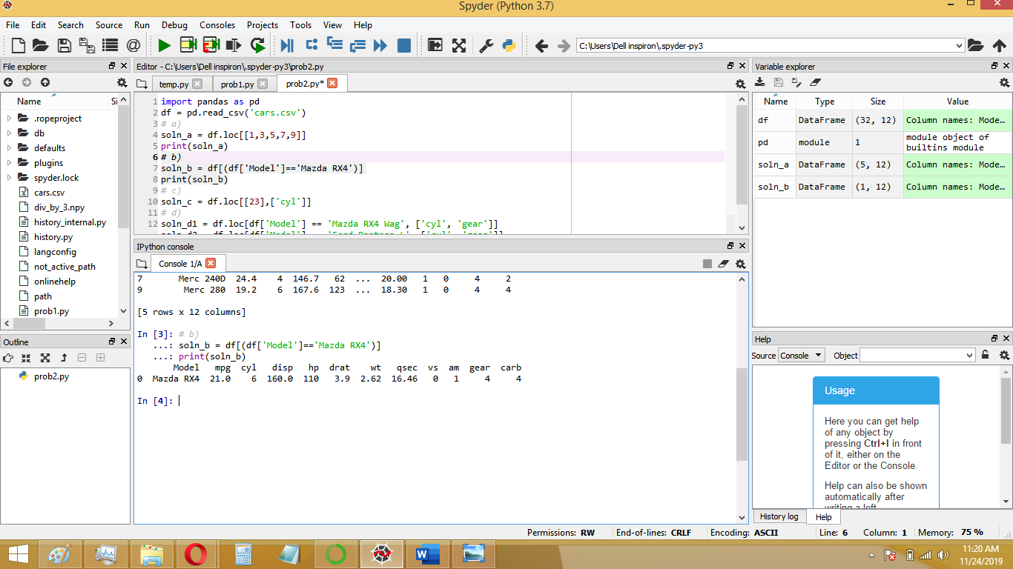

Answer:



c.)

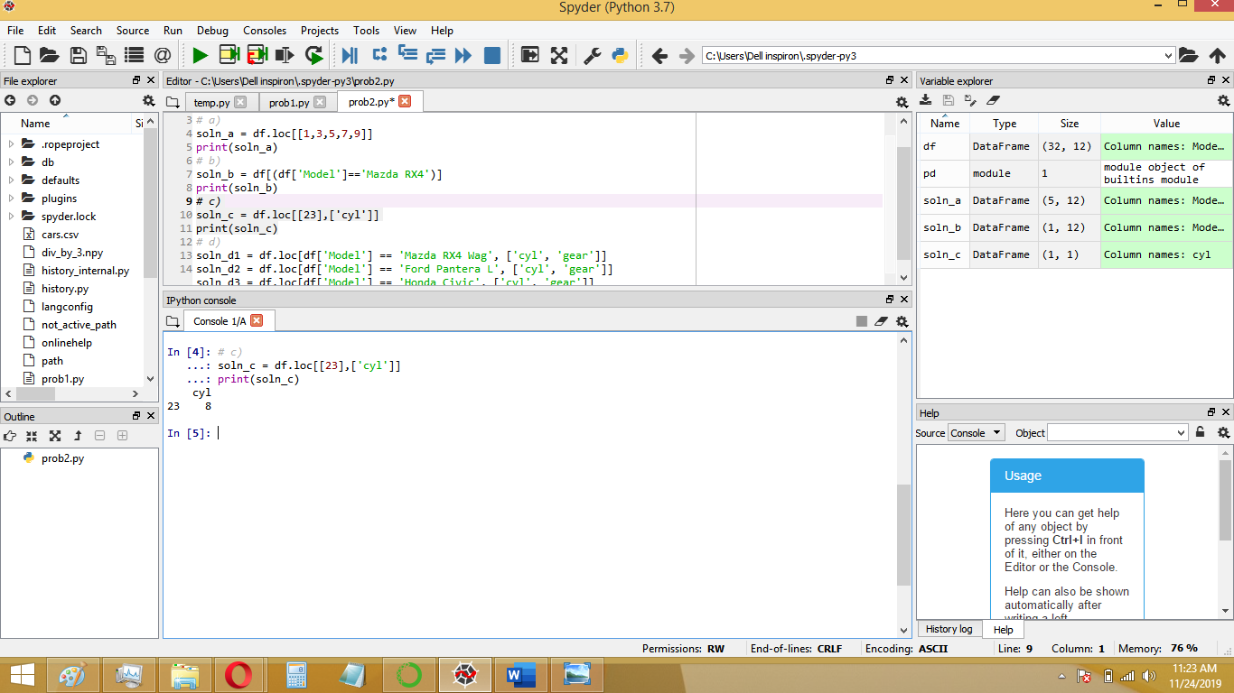

Answer: 8 cylinders.

d.)

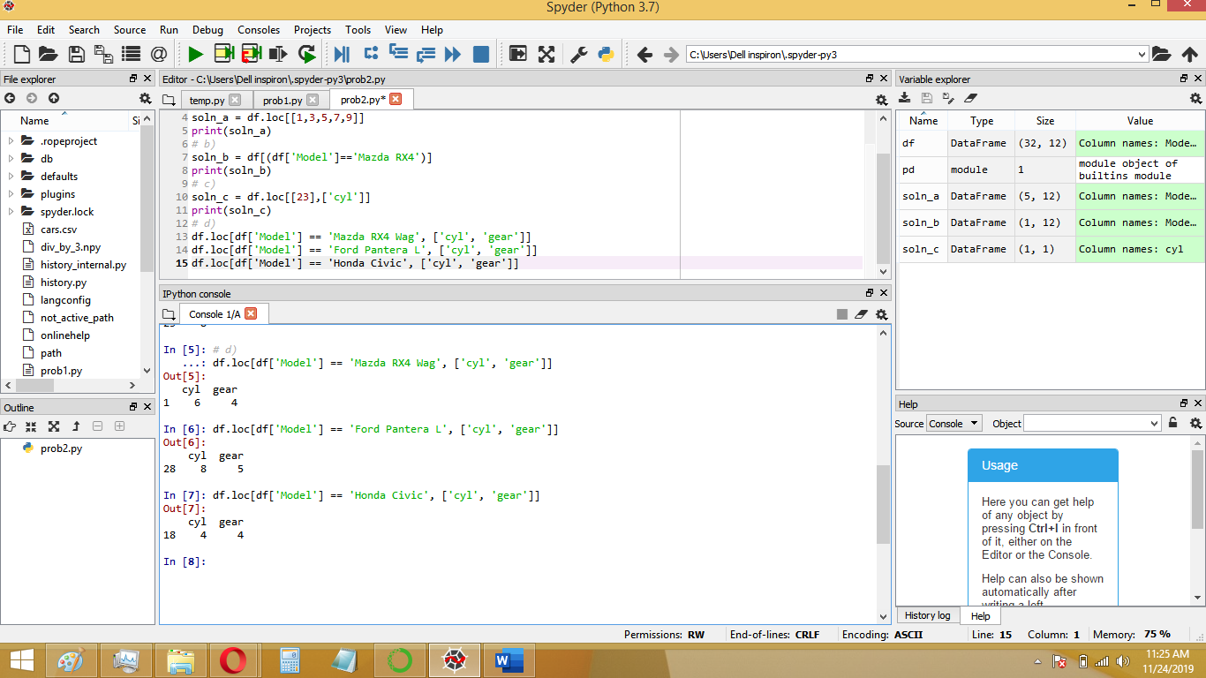

Answer:

|  |  |  |
| --- | --- | --- |
| Model: | No. of cylinders: | Gear type: |
| Mazda RX4 Wag | 6 | 4 |
| Ford Pantera L | 8 | 5 |
| Honda Civic | 4 | 4 |